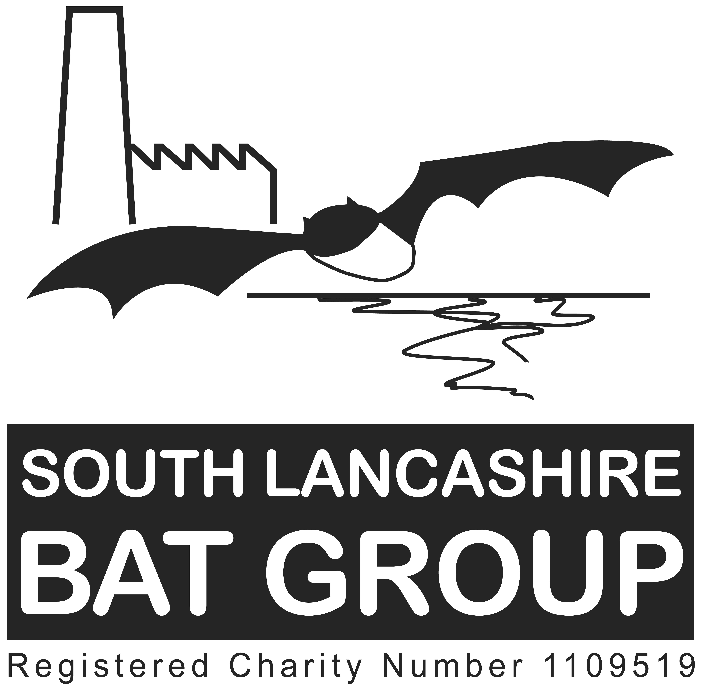

Membership Form

I/We would like to join SOUTH LANCASHIRE BAT GROUP for the forthcoming year.

Name(s)………………………………………………………………………………………………………………………………………………………………………………………………………………………………………………………………
Please include full names of all people in the household who wish to be members.

Address…………………………………………………………………………………………………………………………………………………………………………………………………………………………………………………………………………………………………………………………………………………………………….Postcode……………….
Telephone Number(s)……………………………………………………………………………………………….
Email Address(es)……………………………………………………………………………………………………..

Number of Households (at £5) £……………….
Please make cheques payable to “South Lancashire Bat Group” and send with the form to
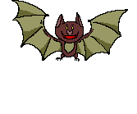South Lancashire Bat Group
PO Box 512
Bury
BL8 9FB, or pay with cash and this completed form at a bat group meeting/event.
Donation £……………….
Total £……………….
Signature(s) …………………………………………………………
…………………………………………………………

I/we are interested in finding out about membership of the Bat Conservation Trust

Gift Aid declaration – 28% Tax back for Bats!!
If you are a UK taxpayer all your future subscriptions and donations to SLBG can go further to help bats as we can claim tax back.

I am a UK Taxpayer and want South Lancashire Bat Group to reclaim tax on all donations or subscriptions I make on or after 6th April 2005.

SIGNATURE……………………………………………….
DATE…………………………………………………………….

Under the Data Protection Act 1998 personal information may be held about you on manual or computer based records. This information will not be passed to anyone outside of the group without your permission. Roost owners details will be passed to relevant recording centres and also be held by the group. You have the right to see and amend any incorrect information held about you and can request to do so at any time. If you do not want records being held please do let us know as soon as possible. South Lancashire Bat Group. ©

